**Assignment 6 - AWS Architecture**

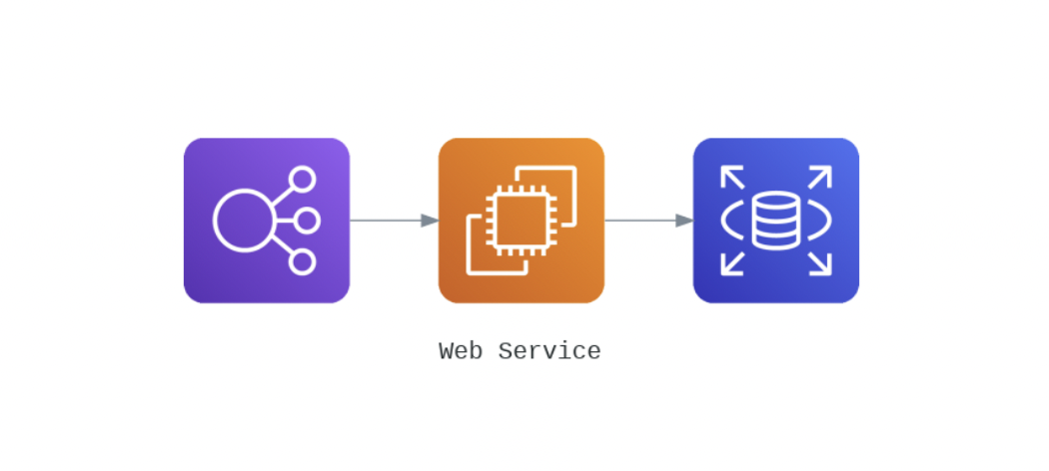Ques: **Complete the below task:**

**1. Explain the below AWS Architecture**

Answer:

The above architecture represents AWS Services configurations. The first image represents the Load Balancer, responsible for handling the load of incoming requests from the network. It uses a health check function to know which EC2 machine is available to forward the request. The second image represents the EC2 machine, which is used for computation. The Load balancer is connected to the EC2 machine using the target group. The third image represents the Relational Database which is connected to the EC2 image we can either connect to the EC2 machine during the creation of EC2 if the RD is available or we can connect the RD to the existing EC2 machine during the creation or after the creation of RD.

**2. Implement the same in the AWS(only do a proper connection between service)**

First I created VPC, subnets, Internet gateway and routing table. Under this VPC I have created an EC2 Machine, RDS, and Load Balancer named demo.

**EC2 Machine named demo:**

Highlighted the instance id for proof of configuration.

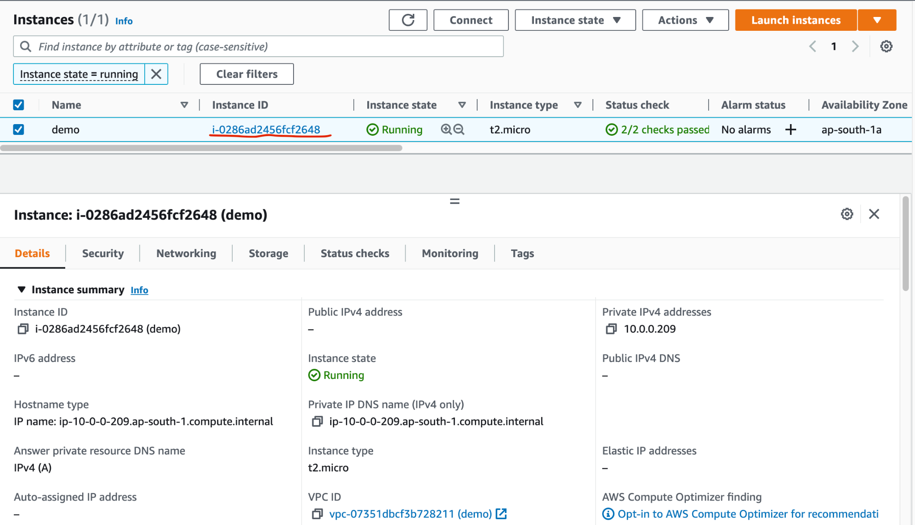

Then I created a Load Balancer for which I created a target group for assigning the EC2 machine.

**Target Group Named demo:**

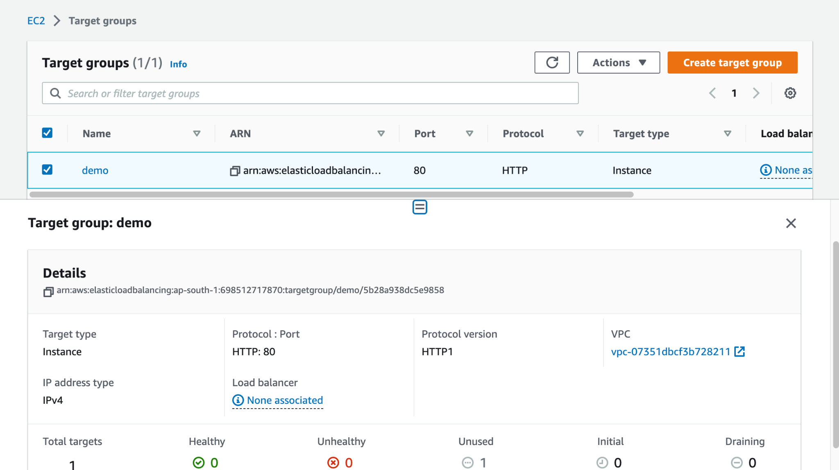

Highlighted the instance id for proof of configuration.

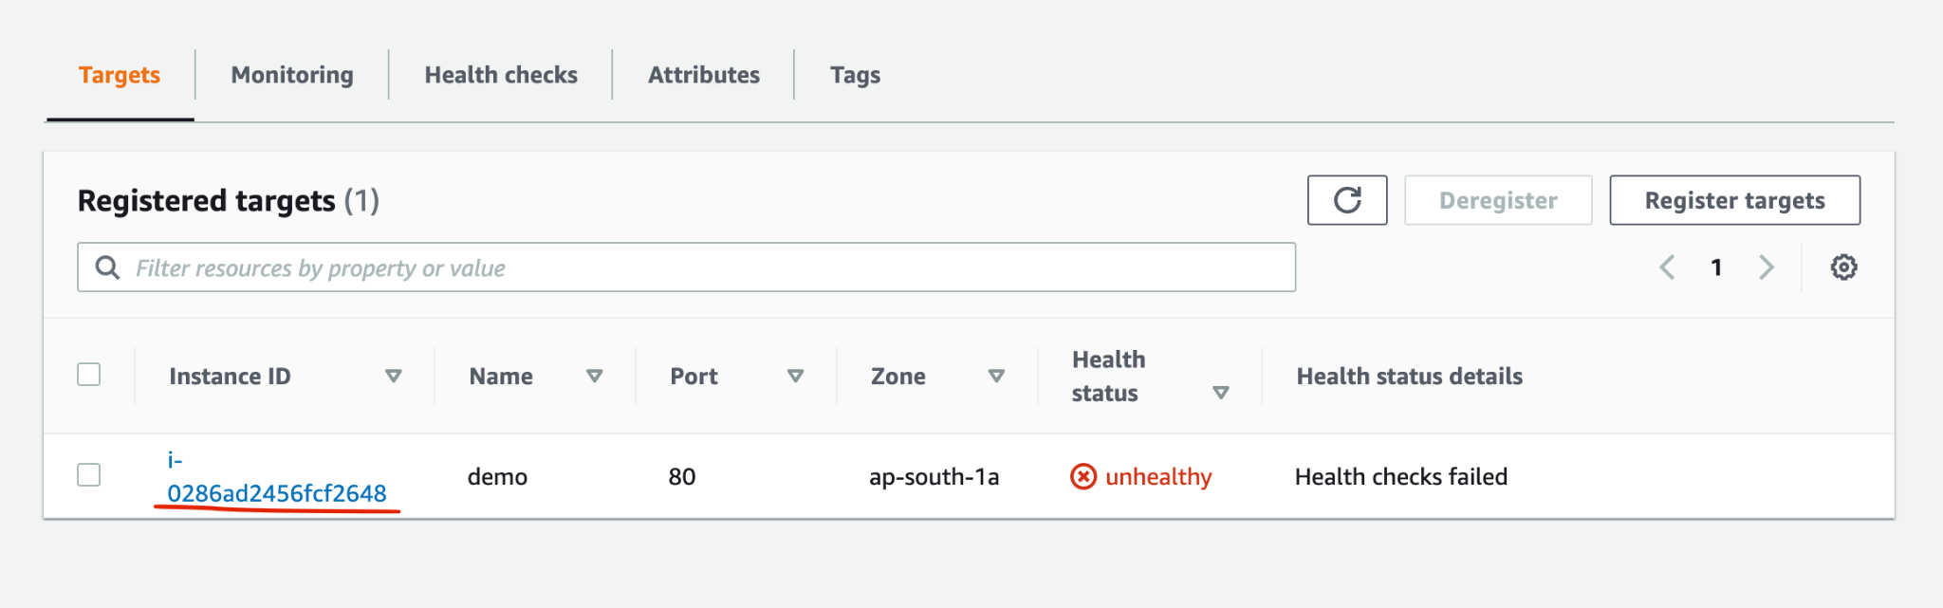

**Load Balancer named demo:**

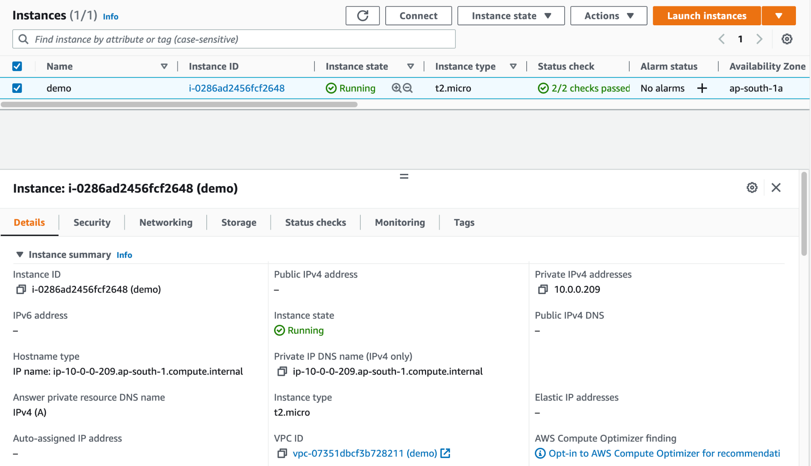

**RDS named demo:**

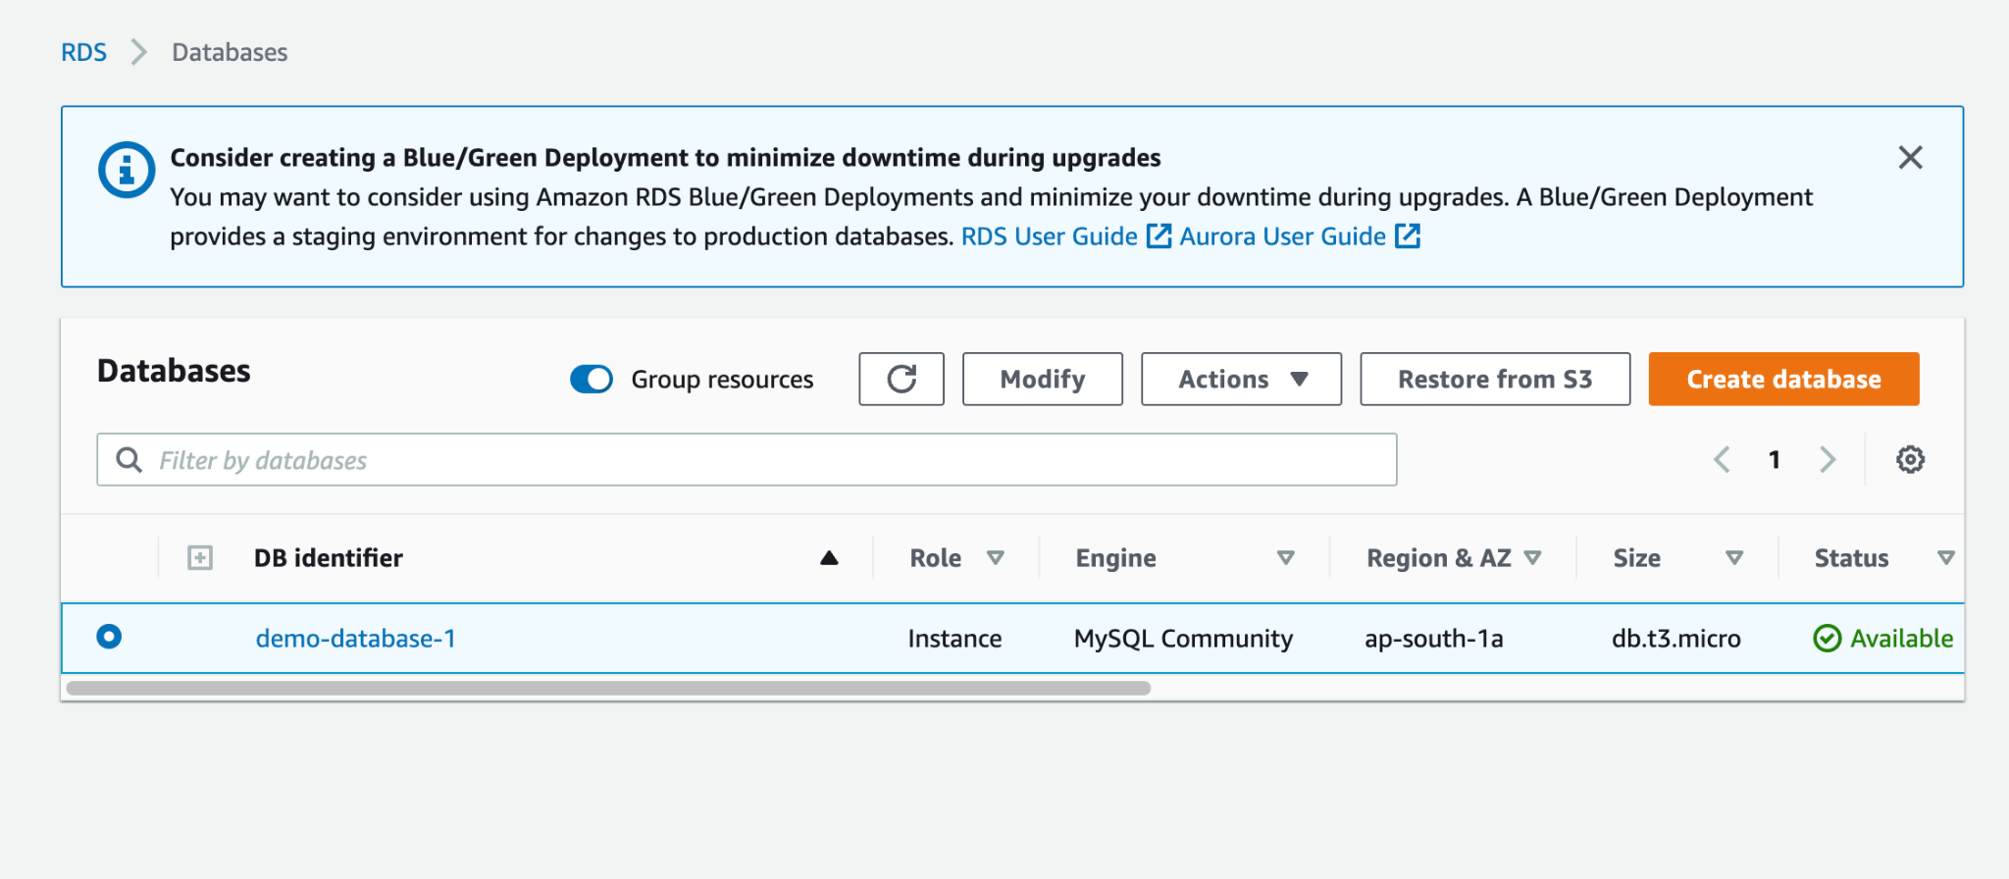

Highlighted the instance id for proof of configuration.

